Physics 20 Lesson 13 Projectile Motion

In Lessons 1 to 9 we learned how to describe the motion of objects which were either moving horizontally or vertically. Now we wish to consider motion where the object is moving both horizontally and vertically at the same moment.

# Independence of vertical and horizontal motion

(See pages 102 to 112 in Pearson for an excellent discussion of projectile motion.)

In Lesson 12, you learned about relative motion. You discovered that if a plane is pointed in a northerly direction and a cross-wind is blowing, the plane will end up flying on a course that is a combination of the plane and the wind. It is important to note that the plane and the wind are independent of each other, but their combined effects produce the final result.

wind

plane

result

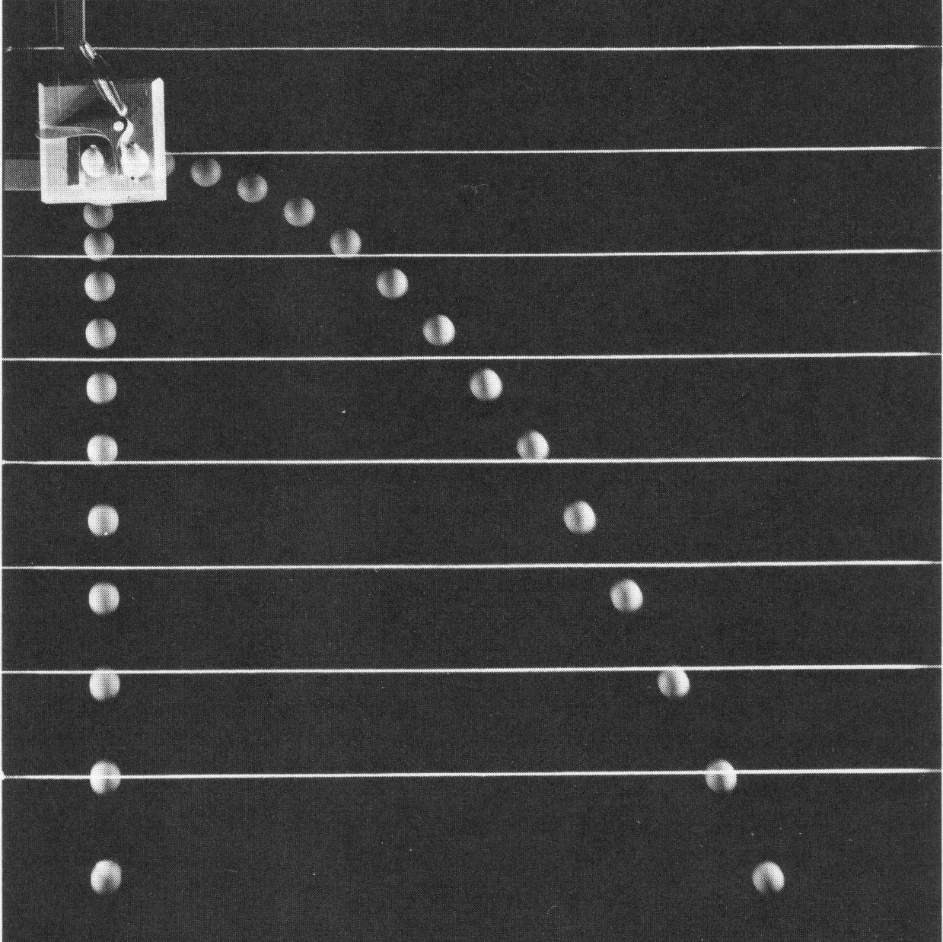For projectile motion, when an object is thrown up at an angle to the ground or projected horizontally off of a table or a cliff, the same **principle of combined independent motions** applies. However, in this case the vertical component of motion is being affected by the acceleration of gravity, while the horizontal component is not affected by gravity. The result is that the object follows a *parabolic* path or trajectory. A parabolic path results because the projectile is falling due to the attraction of gravity and, *at the same time*, it is moving horizontally. In the stroboscopic picture note that the projected ball falls at the same rate as a dropped object. Further, the horizontal component of motion for the projected ball remains constant throughout the fall.

For projectiles the horizontal component of motion is not affected by gravity. Further, for slow moving objects the effects of air resistance are negligible. Therefore, the horizontal component of motion is best described in terms of constant horizontal velocity:

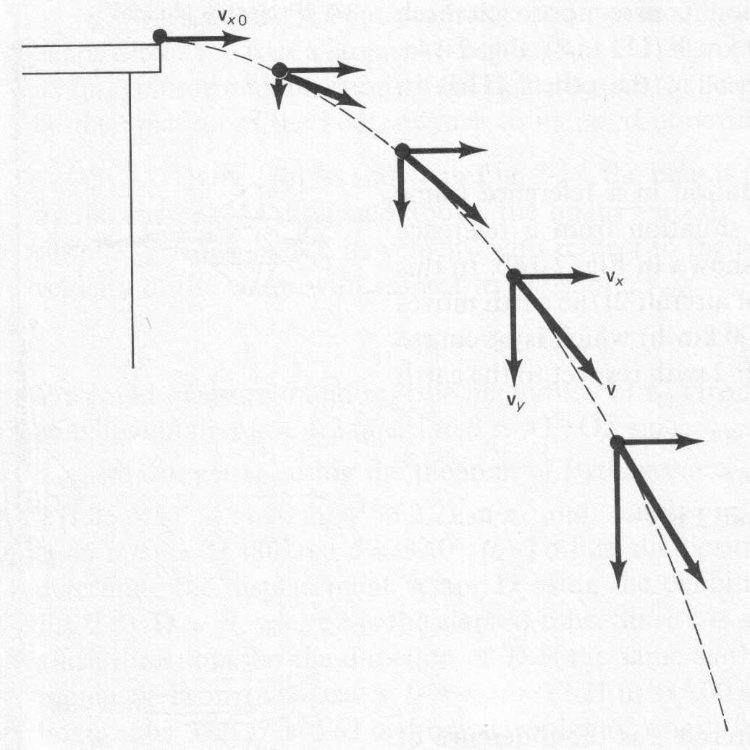 

The vertical component of motion, on the other hand, is affected by gravity. Therefore, the vertical component of the motion is best described by:



(where a = –9.81 m/s2)

A rock is thrown horizontally from a 100 m high cliff. It strikes the ground 90 m from the base of the cliff. At what speed was the rock thrown?

The key to properly solve this question is to realise that since the horizontal and vertical motions are independent of each other we solve them independently. Therefore we **solve the problem as a vertical part and a horizontal part**.

vertical part

It is important to note that although the rock has horizontal velocity, **its initial vertical velocity is zero**.

d = ~~v~~~~1~~~~t~~ + ½ a t2

v1 = 0 (initial motion is horizontal only)

a = -9.81 m/s2

d = -100 m

t = ?

 = 4.5 s

horizontal part

dx = 90 m  = **20 m/s**

t = 4.5 s

vx = ?

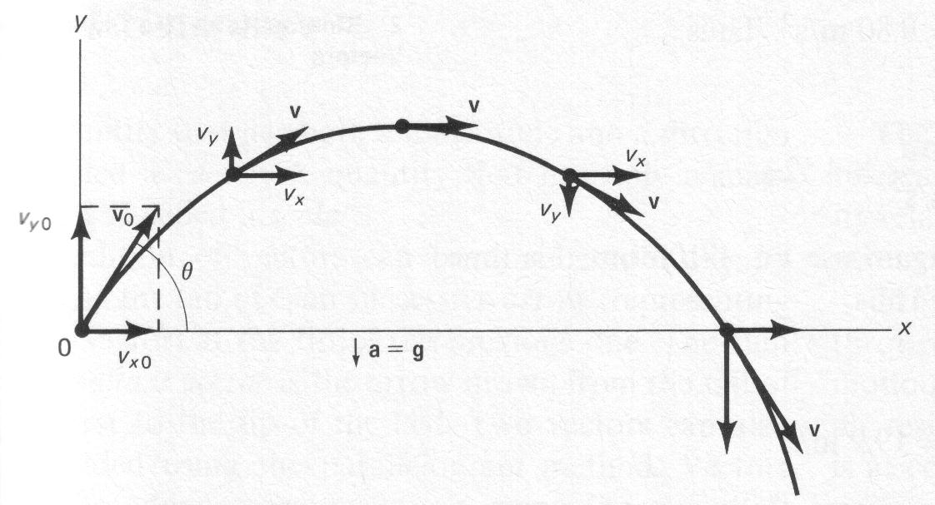When an object is projected up from the ground at some angle () with speed vo, some of the speed is horizontal (vxo) and some of it is vertical (vyo). The key to solving this problem is to calculate the vertical and horizontal components (vxo and vyo) and then treat them separately.

at maximum height

vy = 0

❑



vyo = v sin 

vxo = v cos 

A ball is projected at an angle of 37o up from the horizontal with a speed of 20 m/s.

A. What was the maximum height?

B. How long was the ball in the air?

Δdmax

Δdx

C. What is the range?

37o

20 m/s

vyo = 20 m/s sin 37

vyo = 12.04 m/s

vx = 20 m/s cos 37

vx = 15.97 m/s

maximum height

v22 = v12 + 2 a d

a = -9.81 m/s2

v1 = 12.04 m/s

v2 = 0

dmax = ?

 = **7.4 m**

time in air

v2 = 0 (at maximum height)  = 1.23 s

time up = time down t = 2 x 1.23 s = **2.45 s**

range

vx = 15.97 m/s dx = vx t = 15.97 m/s (2.45 s) = **39.2 m**

# Projectile problems

There are a number of things to keep in mind when doing projectile problems:

* Since the horizontal and vertical components of motion are independent, projectile problems are solved as a *vertical part* and a *horizontal part*.
* If a velocity is given as an angle above or below the horizontal, one must break up the velocity into *horizontal and vertical components*.

❑



vyo = v sin 

vxo = v cos 

* The time that the projectile is in the air is limited by how long it takes for gravity to pull the projectile to the ground. Therefore, the vertical part of the problem is often used to determine the time.
* When a problem asks for the *range* it is asking for the horizontal distance.



A rock is thrown with a speed of 30.0 m/s at 30o below the horizontal from a 150 m sheer cliff. How far away from the base of the cliff did the rock land?

Δdh

150 m

30o

30.0 m/s

vh = 30 m/s cos 30

vh = 26.0 m/s

v1 = 30 m/s sin 30

v1 = –15.0 m/s

time in air range

v1 = –15.0 m/s

a = –9.81 m/s2

d = –150 m

v2 = ?

t = ?





# Practice Problems

1. A rock is thrown horizontally at 10.0 m/s off of a 150 m sheer cliff. What is the range? (55.3 m)

2. A quarterback throws a football at 15 m/s at 40o to the horizontal. What is the maximum height of the ball? What is the range? (4.74 m, 22.6 m)

# Hand-in Assignment

1. A person fires a bullet horizontally from a gun at the same instant that another bullet is dropped from the same height as the rifle barrel. Discuss which bullet will hit the ground first.

2. One day in the jungles of the Amazon, professor Glick was stalking a very rare species of monkey, *projectilus* *avoidicus*. He spotted one up in a tree and decided to shoot it with a dart rifle. If the monkey begins to fall at the *same instant* that the dart leaves the barrel of the rifle, explain why the professor should aim directly at the monkey.

3. A man is standing on the edge of the roof of a building that is 828.1 m high. If he throws an object horizontally from the roof at 12 m/s, how far from the base of the building does the object land? (156 m)

4. A man standing at the edge of a cliff throws a stone horizontally at 40 m/s. The stone lands 360 m from the base of the cliff. How high is the cliff? (397 m)

5. A baseball is thrown at 30o above the horizontal with a speed of 49.0 m/s.

A. How long does it take for the ball to reach its maximum height? (2.50 s)

B. What is the maximum height? (30.6 m)

C. How long is the baseball in the air? (5.00 s)

D. What is the maximum range of the baseball? (212 m)

6. If a stone is thrown at 60o above the horizontal with a speed of 196 m/s, what is the maximum height and the range? (1469 m, 3391 m)

7. An airplane is flying level at 80.0 m above the ground with a speed of 350 km/h. The bombardier wishes to drop food and medical supplies to hit a target on the ground. At what horizontal distance from the target should the bombardier release the supplies? (393 m)

8. A ball is thrown horizontally from a window at 10 m/s and hits the ground 5.0 s later. What is the height of the window and how far from the base of the building does the ball first hit? (1.2 x 102 m, 50 m)

9. An artillery gun is fired so that the shell has a vertical component of velocity of 210 m/s and a horizontal component of 360 m/s. If the target is at the same level as the gun (a) how long will the shell stay in the air and (b) how far down-range will the shell hit the target? (42.9 s, 15.4 km)

*10. A girl standing on the top of a roof throws a rock at 30 m/s at an angle of 30o below the horizontal. If the roof is 50 m high, how far from the base of the building will the rock land? (52.3 m)

*11. A cannon is fired at 30o above the horizontal with a velocity of 200 m/s from the edge of a 125 m high cliff. Calculate where the cannonball lands on the level plain below. (3.7 x 103 m)

*12. A golfer hits a golf ball with a pitching wedge from a tee that is 15 m lower than the green. If the ball leaves the tee at 35 m/s at an angle of 40o to the horizontal and it lands in the hole on the green, what is the horizontal distance from the golfer to the hole? (101.3 m)

(For extra practice do the Practice Problems on pages 107, 109 and 111 in Pearson.)

Building a Projectile Machine

In this activity you and your partner (maximum of two people) are asked to build a projectile machine that is designed to do one of the two tasks below:

1. **A horizontal projectile launcher**. The projectile launcher will be placed on a table in room 205. The projectile must hit the bull's eye target painted on the floor.

2. **A parabolic projectile launcher**. The projectile launcher will be placed in a rectangle painted on the floor. The projectile may be launched at any angle you desire. The projectile must hit the bull's eye target painted on the floor.

The following rules of design and construction **must** be followed:

* The launcher must have a triggering mechanism that holds the launcher in firing position until released.
* No explosives or flammable gases or liquids may be used.
* Any kind of non-lethal projectile may be used.
* The launcher must be designed and constructed by your group. Use of ready made launchers like sling-shots, air rifles, etc. are not permitted.
* Any kind of launcher device may be constructed using readily available materials.
* Your launcher will be required to launch three projectiles in turn.
* If you have any questions, just ask.
* You may test your launcher on site any time prior to the actual completion date.

Evaluation of your device is based on the following criteria:

* Functionality – does it work as a launcher?
* Accuracy/distance – did you hit the target?